YEAR 12

PHYSICS STAGE 3

MID YEAR EXAMINATION 2011

A

B

C

Total |  | / 180 = %

Solutions

TIME

Time allowed for this paper

Reading time before commencing work: ten minutes
Working time for paper: three hours

Materials required/recommended for this paper

To be provided by the supervisor

Question/Answer Booklet
Formulae and Constants Sheet

To be provided by the candidate

Standard items: pens, pencils, eraser, correction fluid, ruler, and highlighters

Special items: non-programmable calculators satisfying the conditions set by the Curriculum Council for this course.

Important note to candidates
No other items may be taken into the examination room. It is your responsibility to ensure that you do not have any unauthorised notes or other items of a non-personal nature in the examination room. If you have any un-authorised material with you, hand it to the supervisor before reading any further.

Structure of this paper

Section | Number of questions available | Number of questions to be answered | Suggested working time (minutes) | Marks available | Percentage of exam
Section One: Short Answers | 13 | 13 | 45 | 54 | 30%
Section Two:  Problem-Solving | 8 | 8 | 90 | 90 | 50%
Section Three:  Comprehension | 2 | 2 | 45 | 36 | 20%
100

Instructions to candidates

Write your answers in this Question/Answer Booklet

Working or reasoning should be clearly shown when calculating or estimating answers. Your answers should be written to 3 significant figures where appropriate.

You must be careful to confine your responses to the specific questions asked and to follow any instructions that are specific to a particular question.

YEAR 12

PHYSICS STAGE 3
MID YEAR EXAMINATION 2011

Section One: Short Response

This section has thirteen (13) questions. Answer all questions. Write your answers in the space provided.

Suggested working time for this section is 45 minutes.

Question 1 (4 marks)

Two students, Paul and Matt, are discussing an experiment to test the nature of sound waves. They imagine a loudspeaker with a dust particle sitting motionless in front of it, and consider what will happen to the particle when the speaker is turned on.
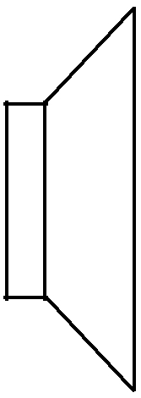

dust particle


Figure 1

Paul says that since there is energy transferred by the wave, the particle will gain energy. A succession of little impulses will push the particle continuously away from the speaker.

Matt agrees that energy is carried by the wave. However, he says the result of the pressure variations will cause the dust particle to move back and forth about its original position.

(a) Which of the two boys prediction is more clearly correct? (1 mark)

Matt's prediction is more correct

(b) Explain the logic of your choice. (3 marks)
1
• Sound is a longitudinal wave created by pressure variations

• The dust particle is moved backwards and forwards by the compressions and rarefactions.
1

• as the wave, or its energy, moves forwards.
1

Question 2 (3 marks)

An aluminium pendulum that is oscillating can be brought to rest rapidly (i.e. damped) as it passes between the poles of a magnet as shown.

(a) State the principle that causes this effect. (1 marks)
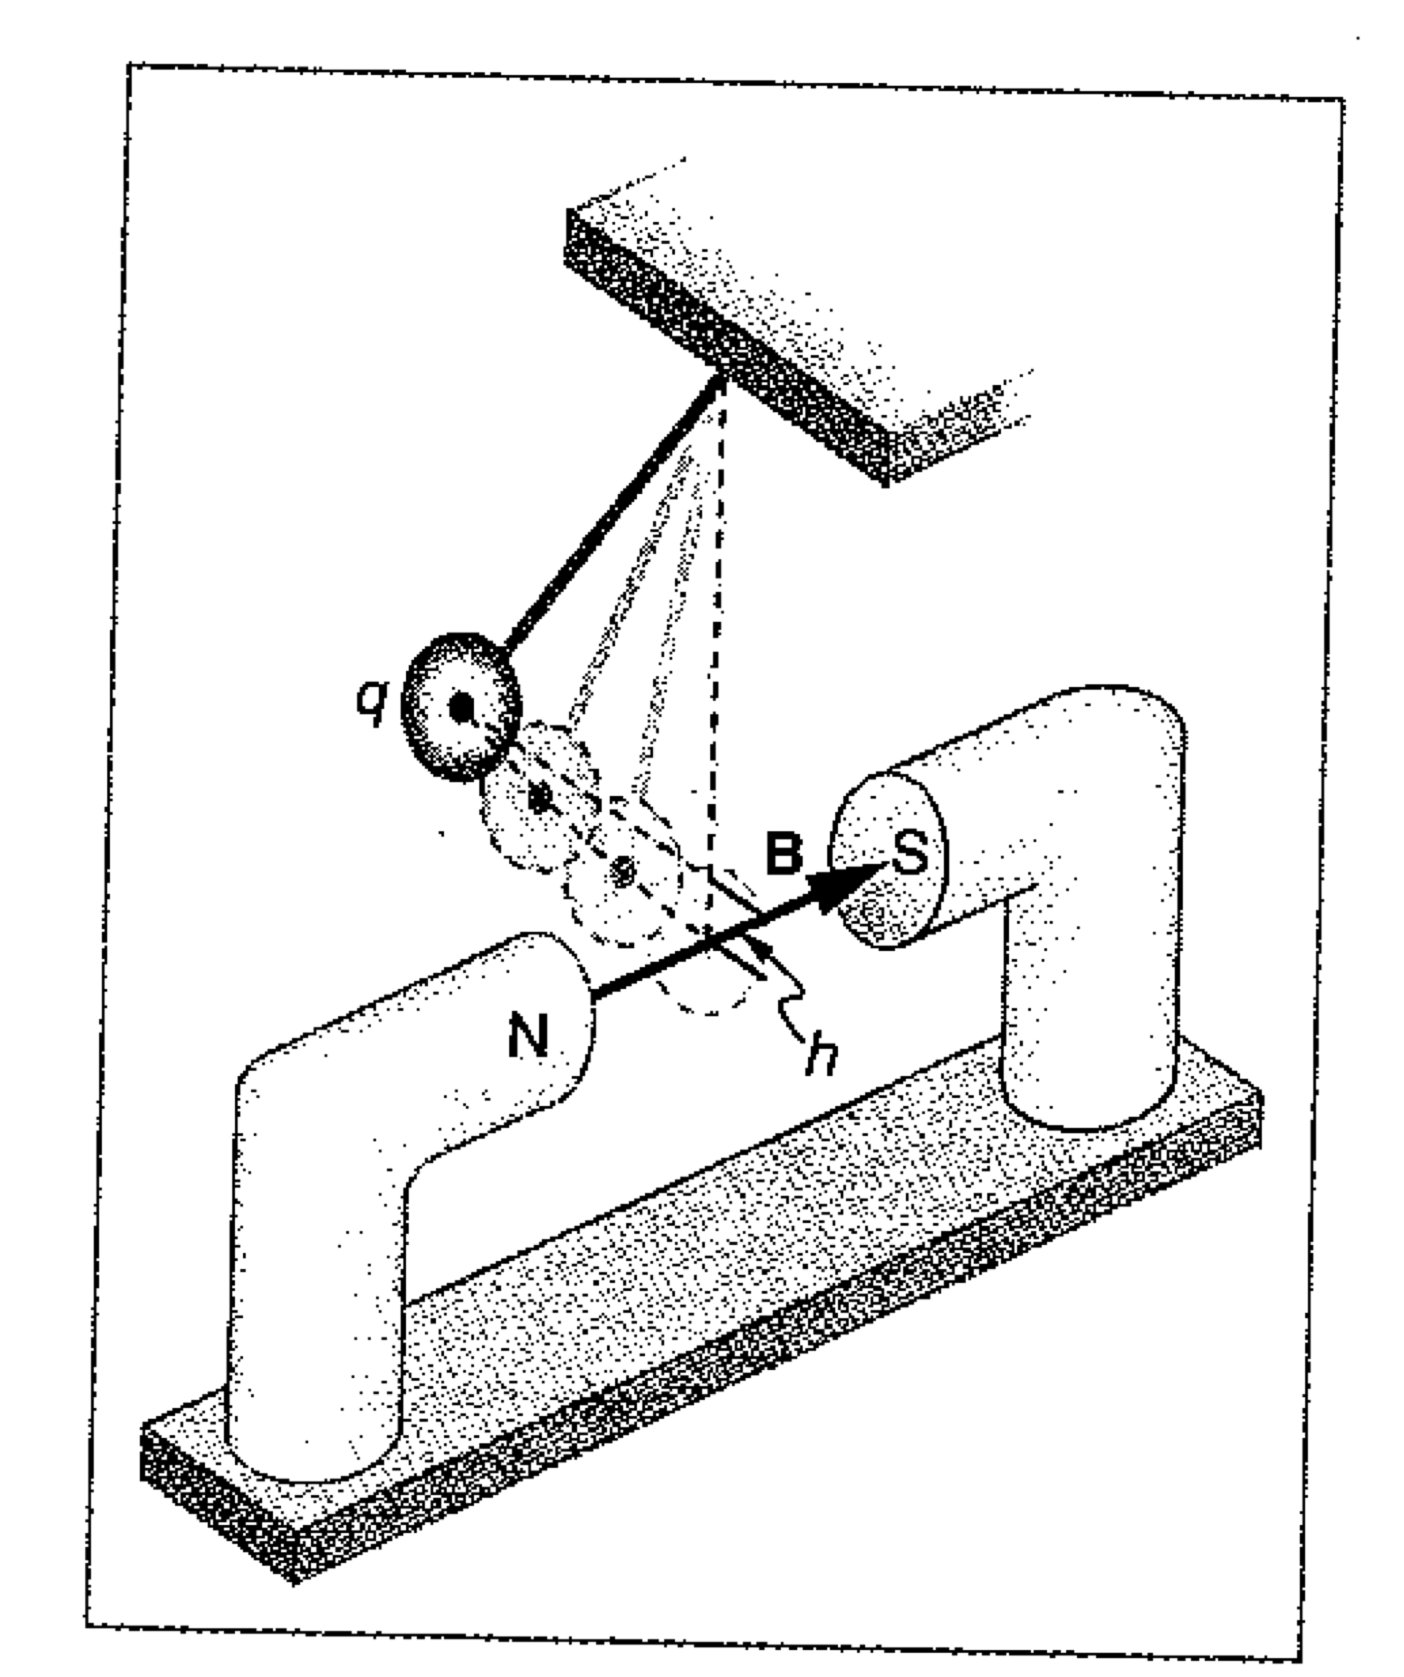
The motion of a conductor through a magnetic
field induces a current that flows in a
direction that opposes the motion of the
conductor (Lenz's Law) thereby bringing it
to a stop quicker.

(b) State two other ways in which the dampening can be increased. (2 marks)

Any 2 of - increased magnetic field strength,
increased area of magnet or increased area of the plate

Question 3 (4 marks)

The picture on a TV set is generated by firing electrons at a screen at a speed of 1.2 x 10⁷ ms⁻¹. Calculate the magnitude of the force exerted on these electrons travelling at right angles to the earth's magnetic field in Perth, which has a value of 66 μT at an angle of 66˚ to the horizontal.
1
F = qvB the electrons are travelling at right angles to B so
2

F = 1.60 x 10⁻¹⁹ x 1.2 x 10⁷ x 66 x 10⁻⁶
1
F= 1.27 x 10⁻¹⁶ N -1 if used Bsin66

Question 4 (4 marks)

An experiment was conducted to generate electricity in a high orbit above the Earth using a satellite and a space shuttle and a 20.7 km long wire stretched between the space shuttle and the satellite. The space shuttle was travelling at a velocity of
7.92 kms⁻¹. Calculate the magnitude of the component of the Earth's magnetic field perpendicular to the motion of the wire to generate a potential difference of 5000 V.
1
ε = Blv so B = ε/lv
2
B = 5000/(20.7 x 10³ x 7920)
1
B = 3.05 x 10⁻⁵ T

Question 5 (4 marks)

When sound waves pass from one medium into another they often refract. In the space below show in a diagram the behaviour of a series of wave fronts refracting at the boundary as sound passes from air into a solid.

State the relationships between frequency, wavelength and wave speed that determines whether or not the sound will refract at angles of incidence other that 0˚.
1
Suitable diagram showing wave fronts refracting at boundary

The relationships are:
• frequency is unaffected
• Wavelength in air < wavelength in solid
• Wave speed air < wave speed solid

Question 6 (4 marks)

A coil of wire has 50 turns and an area of 625 cm². It is rotated steadily at 5.0 revolutions per second within a uniform magnetic field of flux density 0.50 T. Calculate the maximum emf induced in the coil.
1
Emf max = N B A 2π f
2
= 50 x 0.5 x 625 x 10⁻⁴ x 2 x π x 5

= 49 V
1

Question 7 (4 marks)

When electric power is distributed there is a loss of energy. State and describe two sources of the "transmission" loss.

The transmission loss is due to resistive heating. This occurs in the distribution wires.
This creates a voltage drop (V=IR) leading to power loss P = I²R or V²/R.

There is also resistive energy loss in the transformers that are used to vary the voltage and current. In transformers the loss comes about because of hysteresis. The constantly changing magnetic field alters the domains within a metal leading to friction and loss of energy as heat.

Any other suitable description.

Question 8 (7 marks)

Neil is studying standing waves that are set up in a narrow glass tube. He has an audio signal generator and a small speaker that is near one end of the tube, and adjusts the frequency to set up the resonances as shown in the diagram below. The tube is filled with fine dust so that when a resonance is formed the dust indicates the positions of the pressure nodes and antinodes. Although he can see the entire tube, shields prevent him from seeing whether an end is open or closed.
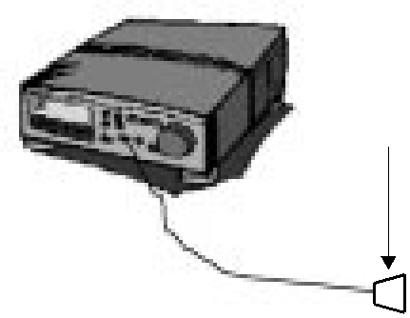

speaker

end shields
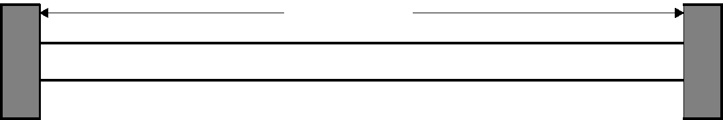

At a particular frequency of 680 Hz, he observes that there are 5 nodes and 5 antinodes.

(a) How many open ends does the tube have? Include a diagram to justify your answer. (3 marks)
1
Even number of nodes and antinodes means the ends are different.
1
So 1 open end
1

(b) If the speed of sound is 340 ms^{–1}, what is the length of the tube? (Disregard end effect). (4 marks)
1
680 Hz = 9f₁ f₁ = 75.5 Hz

1
v = f₁ λ
1
v/ f₁ = λ 340/75.5 = 4.5 m λ = 4L so 4.5/4 = L
1
L = 1.125 m = or 1.13 m (3 sig fig).

Question 9 (4 marks)

You are wiping the surface of the main dining table at home after a meal, when quite accidentally you strike a fork that then slides off the table at a horizontal speed of 3.50 ms⁻¹.

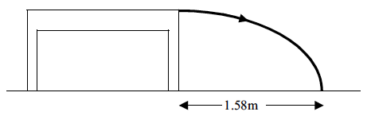
If the fork lands on the ground, 1.58 m horizontally from the edge of the table as shown in the diagram above, how high off the ground is the top of the table?
1
s = v_{H} t t = s/ v_{H}

1
t = 1.58/3.50 t = 0.451 s

1
s = ut + 1/2 at²
1

= 0 + 4.9 x 0.451² = 1.00 m

Question 10 (4 marks)

Andrew and Holly have a method for determining the speed of sound. They go to a large oval near to where they live. Andrew beats a drum at a rate of exactly two beats per second. Holly then walks away from Andrew until the sound of the drum is heard at the precise instant Andrew is seen to hit the drum. The distance from the drum to Holly at this point is 167 m.

Calculate the speed of sound.

Time between beats = period = 0.5 sec
1
1
Speed = Distance/ Time
1
= 167/0.5

= 334 m/s
1

Question 11 (4 marks)
Sam throws a 0.700 kg javelin with a velocity of 18.0 ms⁻¹ at an angle of 42.0° to the horizontal. When he releases the javelin, it is 2.10 m above ground level. He was hoping to beat his best throw of 34.0 m. Does he achieve this? Justify how you arrived at your answer.
1
v_{H} = vsin42˚ = 12.04 ms⁻¹
1
v_{v} = vcos42˚ = 13.38 ms⁻¹ b
1

s_{V} = v_{v}t + 0.5gt² =-2.1 = 12.0t + 4.9 t² t = 2.61s
1
s_{H} = v_{H}t = 13.38 x 2.61 = 34.97 m = 35.0 m (3 sig figs)

Question 12 (4 marks)

The cone of a loudspeaker is turned on at time t = 0 s, and is driven back and forth such that its position as a function of time is as shown the diagram below.
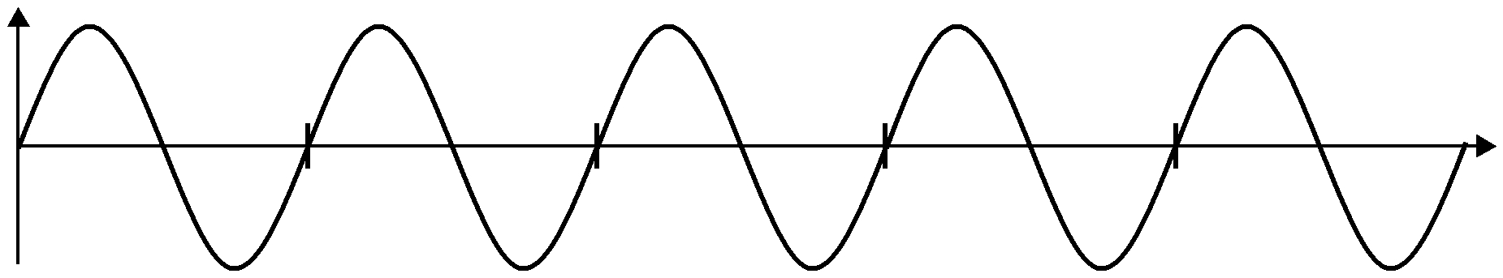
Position
Time (s)
0.005
0.00
0.010
0.015
0.020

(a) What is the frequency of oscillation of the speaker cone? (2 marks)

1
The period is 0.005 sec. Frequency = 1/period, so frequency = 1/0.005
1
= 200 Hz

(b) What is the wavelength of the sound transmitted through the air by the loudspeaker? (Take the speed of sound in air = 340 ms^{–1}) (2 marks)

1
v = f λ
1
λ= v/f = 340 / 200 = 1.70 m

Question 13 (4 marks)
In Galileo’s time an experiment was performed where a cannon ball was dropped from the mast of a ship moving at 3.0 ms⁻¹. Neglecting air resistance, if the mast height is 12.0 m and the ball has a mass of 5.0 kg calculate where the ball will land on the deck relative to position X as shown in the following diagram. Explain your answer.

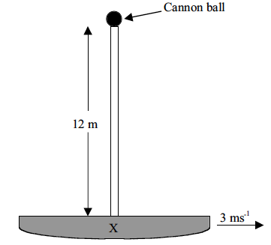

• The ball will land at point x.

• The cannon ball at the point of release has a horizontal component of velocity that is the same as that of the ship 3.0 ms⁻¹.

• This component is constant if air resistance is neglected.

• The vertical component of velocity of the cannon ball will start at 0.0 ms⁻¹ and will accelerate towards the ground due to gravity, falling in line with the mast to strike point x, which is immediately below the starting position of the cannon ball at the top of the mast.

End of Section One

THIS PAGE HAS BEEN LEFT DELIBERATELY BLANK

YEAR 12

PHYSICS STAGE 3
MID YEAR EXAMINATION 2011

Section Two: Problem-Solving

This section has eight (8) questions. Answer all questions. Write your answers in the space provided.

Suggested working time for this section is 90 minutes.

NAME:_______________________________________

Question 1 (12 marks)

Whilst visiting friends in Scotland Jeremy hears a sound coming from a fireplace on a very windy day. Using his knowledge of physics he concludes that the wind must be generating a standing wave in the chimney that was acting as a pipe open at both ends. He estimates that the sound is at a frequency of 30 Hz.

(a) Draw labelled sketches of the fundamental and the next possible harmonic of the standing wave Jeremy considers existing in the chimney. Justify the sketches you have drawn.
(4 marks)
Fundamental

Fundamental = f₁ with two antinodes and 1 node, λ = 2L

Next Harmonic

Fundamental = 2f₁ with three antinodes and 2 nodes, λ = L

(b) If the sound heard by Jeremy was due to a fundamental standing wave, calculate the length of the chimney.
(4 marks)
1
1
v = fλ open pipe λ = 2L
1
346 = 2L x f 346/30 = 1.53 m = 2L
1
L = 10.3/2 = 5.77 m

(c) Jeremy wishes to reproduce the sound he heard on a musical instrument. He has a double bass and a violin. Would it matter which instrument he used to reproduce the sound? Explain.
(4 marks)

• Yes it does matter.

• A low frequency is required. Frequency is proportional to length

• A double bass is a large instrument with long strings needed to produce a low frequency

• A violoin has much shorter strings and can only produce higher frequencies

Question 2 (14 marks)
A simple d.c. electric motor consists of a 10.0 cm x 10.0 cm square plane coil of 200 turns and resistance 0.300 Ω that can rotate in a radial field of 0.4 Wbm⁻². The coil is wound on a core and the current is fed in from a 12.0 V battery through a split ring commutator.

(a) What is the starting current in the coil? (3 marks)
1
V = I R
1
1
I = 12/0.3 = 40 A

(b) Draw arrow(s) on the diagram above to show the direction of the current in the coil and the direction of the forces on all sides of the coil.
(2 marks)
LHS current in and F down

(c) Calculate the torque on the coil. (4 marks)
1
Force on one side F = ILBN
1
Couple or Torque due to both sides C = 2 r F
1
Therefore torque C=2x0.05x40x0.1x0.4x200
1
Torque in radial field is C = 32 Nm

(d) Explain what happens to the current as the motor spins faster.
(2 marks)

• The net current is reduced as the motor spins faster
• due to the back emf
(e) At a speed near maximum the current is 2.00A. What is the back emf at this speed? (3 marks)
1
Ohm’s law for the motor is εa- εb = IR

(where εa is the applied e.m.f. and εb is the back e.m.f. induced in the coil due to the motion of the armature through the field).
1
1
Thus 12- εb = 2 x 0.3 Thus εb =11.4V

Question 3 (11 marks)

A calculator runs on a 9.0 V battery or a transformer connected to a 240 V power supply. The primary coil of the transformer has 2000 turns and the transformer is 75% efficient.

(a) A current of 500 mA is required in the secondary coil to operate the calculator. Calculate the power output of the transformer. (3 marks)
1
1
P = V I = 9.0 x 0.5

1
= 4.5 W

(b) What is the power input? (3 marks)
1
Efficiency = power output
power input

power output = 75% x power input
1
1
power input = 4.5 x 100/75 = 6.0 W

(c) What is the current in the primary coil? (3 marks)
1
I = P/V
1
1
= 6/240 = 25 mA

(d) Why should soft iron and not steel be used as the core of an electromagnet? (2 marks)
The domains in soft iron can be aligned and realigned rapidly with changes in the flow of electricity whereas steel does not.

Question 4 (10 marks)

Consider the following graph of displacement versus time for a particle K in a certain transverse mechanical wave.

40
50
60
70
80
20
10
30
Time (ms)
Displacement (mm)
rhs
20
-20
10
-10

(a) What is the approximate amplitude of the wave? (1 mark)

The approximate amplitude is 25 mm or 2.5 x 10⁻² m (allow 20 mm)

(b) What is the approximate frequency and period of the wave? (4 marks)
1
The period of the wave is approximately 80 ms.
1
f = 1/T
1
f = 1/(80 x 10⁻³) = 12.5 Hz
1

(c) Describe the motion of particle K at (2 marks)

(i) t = 35 ms
A particle K would be increasing its amplitude in a positive direction (moving away from mean point of oscillation)

(ii) t = 60 ms
A particle K would be decreasing its amplitude in a positive direction (moving back towards mean point of oscillation

(d) If this wave is progressing at 75 ms⁻¹, what is the distance between successive troughs? (3 marks)
1
v = fλ
1
75 = 12.5 x λ λ= 75/12.5
1
λ = 6.00 m

Question 5 (9 marks)

Two speakers are mounted on a wall in the school gym. One speaker is at head-height and the other is exactly 3.0 m directly above it. The speakers are connected to the same amplifier, and emit sound waves in phase with a wavelength of 2.0 m. The speed of sound in air is 340 ms^{–1}. (Note: the diagram is not to scale).
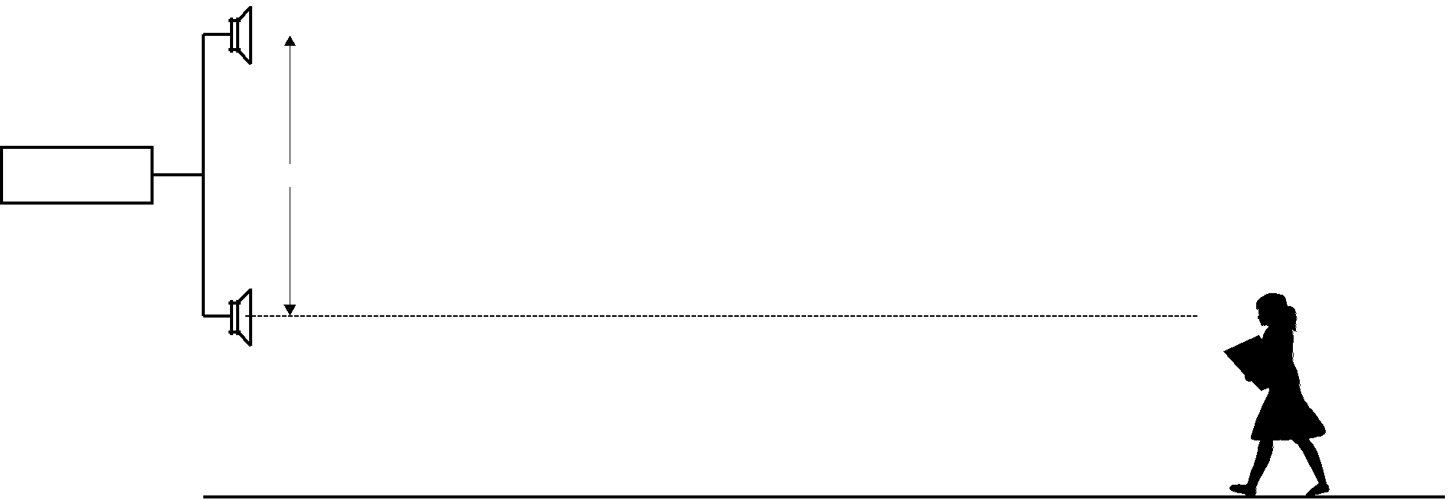

3.0 m

Figure 2

A student walks from the far end of the gym towards the lower speaker. Although the sound is quite audible, at certain distances from the speaker it becomes soft and then increases again.

(a) At what distance from the lower speaker would the sound level first become a minimum? (4 marks)
1
“First becomes a minimum” means path difference = half a wavelength
1
λ/2 = 2/2 = 1 m
1
Speaker distance = 3m, means that the other distances are 4 and 5 m.
1
So “Distance from bottom speaker” = 4 m.

(b) Name the effect that creates the sound intensity that occurs at this point. (1 mark)

Destructive interference

(c) At what distance from the lower speaker would the sound level first become a maximum? (4 marks)

“First become a maximum” means path difference = a full wavelength
1
λ = 2 m
1
let bottom distance = x, and hypotenuse = x + 2.
1
(x + 2)² = x² + 3².
1
4x = 5, x = 1.25 m
Question 6 (9 marks)

A lady lives in a house close to the main highway. She notices sometimes when a truck is accelerating past the house that the metal grill on the front of her electric fire starts to vibrate.

(a) What would be a reasonable explanation of this effect? (2 marks)

• This is due to resonance
• The truck produces a forcing vibrations that matches the natural frequency of the fireplace

(b) The electric fire grill consists of a set of 4 steel rails attached at each end to a guard rail as in the following diagram.

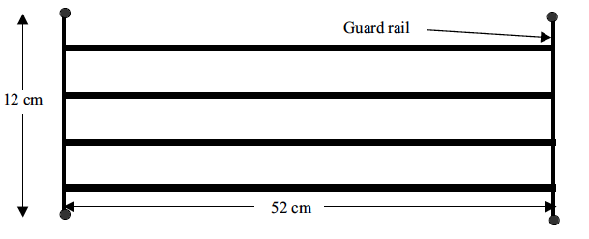

Using the diagram above draw onto the top rail the wave pattern occurring when it is vibrating at its lowest frequency possible. (1 mark)

The diagram is a half wavelength envelope with a node at each end and antinode at the centre

(c) Using an appropriate value for the speed of sound in the rails, calculate the lowest frequency being emitted by the truck when the vibration first starts to occur. (2 marks)

An appropriate speed of sound of around 5.2 x 10³ ms⁻¹ would exist in steel. Any value well above 346 ms⁻¹ in the 1000 ms⁻¹ would be acceptable.

v = fλ
1

5200 = f x 2L = f x 1.04m
1

5200/1.04 = 5000 Hz

(d) This same lady plays guitar in a local heavy metal rock band. She has noticed that when tuning her bass guitar she gets a peculiar effect. When a pure 256 Hz note is sounded from her electronic tuning device at the same time as she plays her top string the volume seems to get louder and softer regularly with time. Explain this effect. (2 marks)

This effect is known as beats.

The electronic tuning device and her electric guitar are slightly different frequencies

(e) She estimates this ‘thrumming’ effect to occur once every 0.2 s but notices that when the top string is tightened this time decreases. Calculate the frequency with which the bass string was vibrating before it was tightened. (2 marks)

As f = 1/T, 0.2s implies a beat frequency of 5 Hz

If she tightens string frequency is increasing (decreasing period), so beat frequency is increasing so her original guitar frequency was 256+5 = 261Hz

Question 7 (16 marks)

Katie has got her kite stuck in a tree. The kite is 7.90 m above the ground. She stands 3.42 metres from the base of the tree and throws a stone at the kite to try and dislodge it. When the stone leaves her hand it is 1.50 m above the ground. When the stone reaches the kite it is moving horizontally. Ignore air resistance in your calculations.

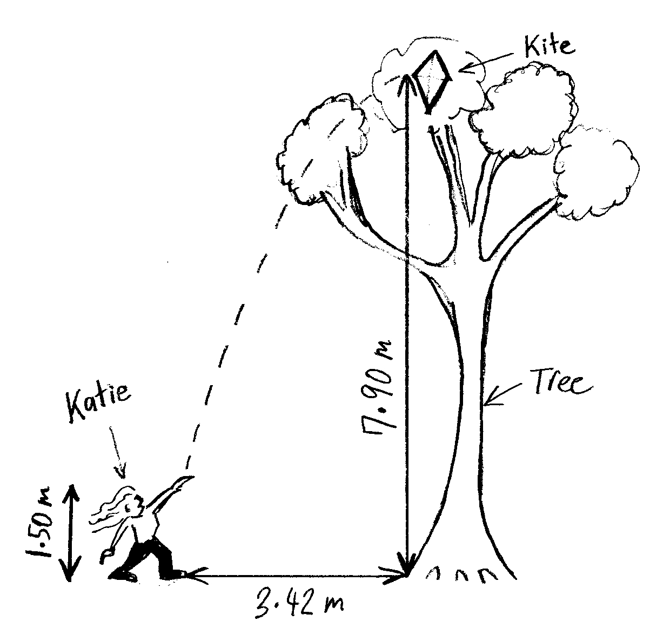

(a) Calculate the time taken for the stone to reach the kite. (6 marks)

If moving horizontally stone is at max height.
1
At max height v_{v} = 0, s_{v} = 7.90 – 1.50 = 6.40 m
Using v² = u² +2as in the vertical, up is positive convention
Insert values 0 = u² – (19.6 × 6.40)
1
u² = 125.44 m²/ s²
1
u_{v} = 11.2 m/s up
1
time to max height from v = u + at, t = (v – u) / a
1
solve for t = (0 – 11.2) / -9.8 = 1.14 s
1

(b) Calculate the acceleration of the stone just before it hits the kite.
(1 mark)
a = 9.80 m s⁻² down (or negative, if up previously stated as positive)

(c) Calculate the initial velocity of the stone just as it left Katie’s hand. (6 marks)
1
s_{v} = 3.42 m in t = 1.14 s
1
1
∴ v_{v} = s/t = 3.42/1.14 = 3.00 m s⁻¹

Use pythagoras
1
1
v =√(11.2² + 3²) = 11.6 m/s

1
angle = arctan 11.2/3 = 75.0° to the horizontal

(d) In reality, a force due to air resistance acts on projectiles close to Earth. Sketch a modified flight path for the ideal projectile below to demonstrate this. (2 marks)
• max height reduced
• steeper descent angle
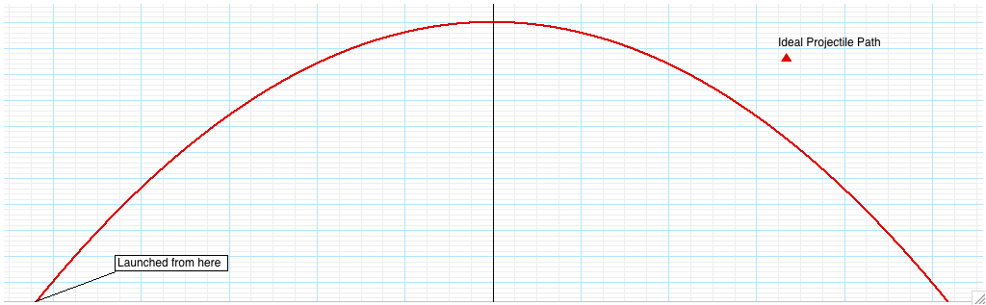

Circle the correct response below. It would it take more time for the projectile under the influence of air resistance to: (1 mark)

A Reach maximum height from the launch height.

B Descend from maximum height back to the ground, level with launch height.

Question 8 (9 marks)

(a) A charged particle with a speed or 3.0 x 10⁶ ms⁻¹ enters a magnetic field of density of 2.0 mT perpendicular to its direction of travel as in the following diagram.

Magnetic field into page

(i) Suggest what type of particle this might be. (1 mark)

an electron (as indicated by right hand slap rule)

(ii) Calculate the force acting on the particle. (3 marks)
1

F = qvB
1

F = 1.60 x 10⁻¹⁹ x 3.0 x 10⁶ x 2.0 x 10⁻³
1

F = 9.60 x 10⁻¹⁶ N at right angles to direction of travel

(iii) If the magnetic field strength was increased, describe the effect this would have on the path of the particle. (1 mark)

The radius of curvature would be reduced.

(b) Blood contains positive and negative ions in solution. The diagram below shows a model used to demonstrate the principle of an electromagnetic flow meter that is used to measure the rate of blood flow through an artery. When a magnetic field is produced by the electromagnet, a potential difference is developed between electrodes X and Y.

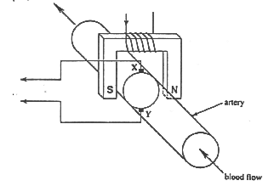

Use the principles demonstrated in part (a) to explain the operation of the flow meter. (4 marks)

• The ions move through the poles of the magnet, experiencing a force (F = Bqv)

• that moves the positive ions move towards X and the negative towards Y

• This causes an e.m.f. ε = Bvl

• The faster the flow (v) the greater will be the e.m.f

End of Section Two

YEAR 12

PHYSICS STAGE 3
MID YEAR EXAMINATION 2011

Section Three: Comprehension

This section has two (2) questions. Answer all questions. Write your answers in the space provided.

Suggested working time for this section is 45 minutes.

NAME:_______________________________________

Question 1 (18 marks)

Determining a Magnetic Force

An experiment is set up as shown in the diagram below. A rigid rod carrying an electric current is suspended between the poles of a magnet, and a sensitive balance measures the force exerted on the rod. An ammeter measures the current. The current interacts with the external magnetic field to generate a force where F = BI

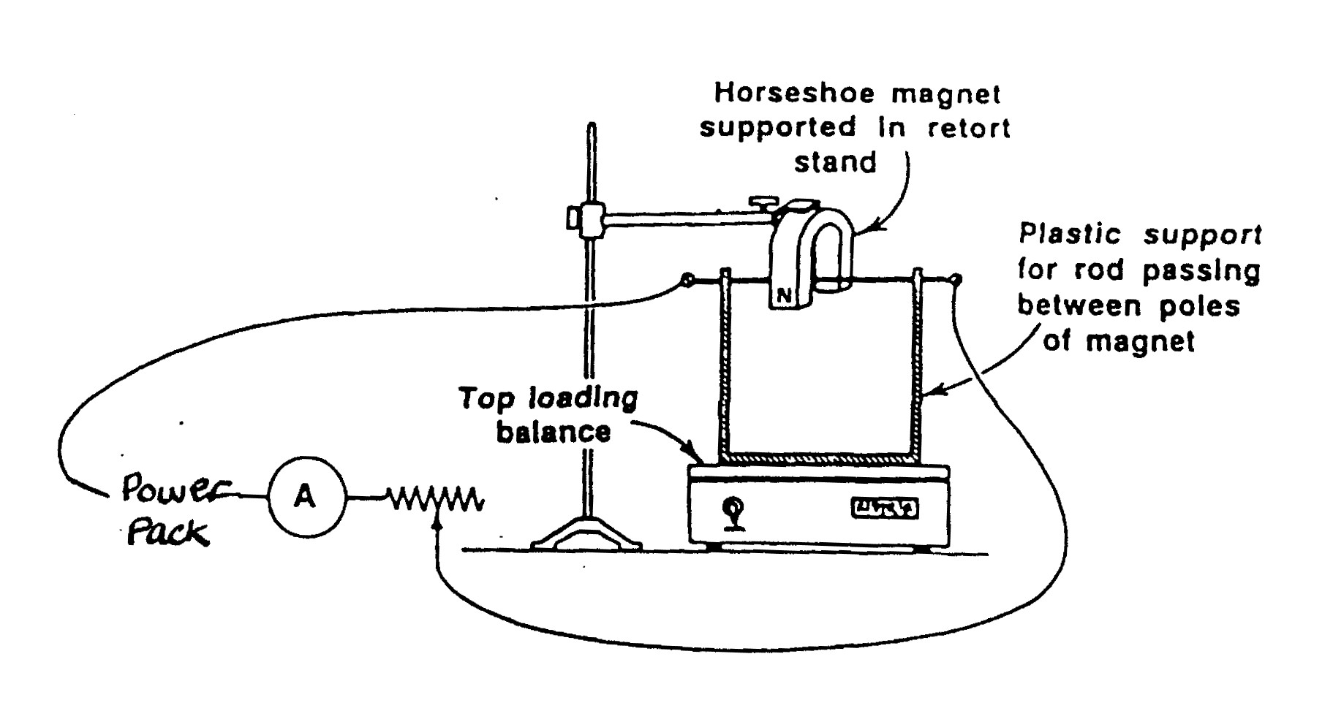
When the experiment is ready to begin the ‘tare’ button on the top loading balance is pressed. This zeros the reading on the balance.

Adjusting the variable resistor varies the current and the following readings were obtained.

Current  (Amperes) | 2.0 | 3.0 | 4.0 | 5.0 | 6.0 | 7.0 | 8.0
Balance reading (milligrams) | 1.3 | 1.9 | 2.4 | 3.0 | 3.5 | 4.1 | 4.7
Force = mg  (x 10⁻⁵ N) | 1.27 | 1.86 | 2.35 | 2.94 | 3.43 | 4.02 | 4.61

(a) Process the data above so that you will be able to plot a graph of F v I.
(2 marks)

1 mark for Title (Force), 1 for values
(b) Plot a graph of F versus I on the graph paper provided. (5 marks)
Title 1, Axes and Units 1, Linear Scale 1, Plotted points 1, Line of Best Fit 1

(c) Determine the gradient of the slope of your graph. (3 marks)

1 mark for Triangle on Graph
Calculation of rise/run (from graph) ΔF/ΔI = 5.63 x 10⁻⁶ NA⁻¹ 1 Value, 1 Unit
(d) What does the gradient of the graph represent? (2 marks)

• Gradient represents ΔF/ΔI = Bl

•The product of flux density and length of conductor in the magnetic field

(e) Using the gradient from your graph, calculate the magnetic field strength between the poles of the magnet if the wire between the poles has a length of 36.5 mm. (3 marks)
1
ΔF/ΔI = 5.63 x 10⁻⁶ NA⁻¹ = Bl
1
B = (5.63 x 10⁻³)/ (3.65 x 10⁻² m)
1
B = 1.54 x 10⁻⁴ T

(f) Indicate on the diagram the direction of current flow through the rod. (1 mark)

Right to Left (Right Hand Slap Rule)

(g) Suggest 2 possible reasons why the graph does not pass through the origin? (2 marks)

Any 2 of
A non-linear relationship when I , 2.00 A
Ammeter not zeroed correctly
Power loss at low current affecting readings
Error in reading the values from ammeter or similar justified reasons.

'Human error' without explanation is incorrect.

Question 2 (18 marks)

Physics in the Kitchen

The applications of science in the kitchen have been growing steadily and almost unnoticed over the years. Time switches and thermostatically controlled cookers are commonplace and the idea of cooking with infra red and microwaves nowadays barely raises an eyebrow. One of the more recent developments is to make use of electromagnetic induction in cooking. A current is induced in pans but the cooking stove itself never gets hot, so you can only ever burn yourself on the saucepans or their contents.

Inside the cooktop there are coils, each one corresponding to one of the cooking areas marked out on the glass-ceramic top. To start cooking, a rapidly alternating current is passed through a coil; this generates an oscillating magnetic field around the coil, which in turn induces an electric current inside the cooking vessel. An electric current can be induced in anything metallic, but since a vessel of optimum resistance is required copper is ruled out. Iron or steel can be used and these materials have the advantage that the induced current tends to be confined to a thinner layer that increases the resistance and hence the power dissipated in the utensil. If a copper kettle is used a device automatically cuts in to limit the current and the stove turns itself off if a pan boils dry. An oscillator produces the high frequency current needed, which is over 18 kHz, and the device runs off the standard 240 V, 60 A power supply.

Some of the above principles are also used on a different scale in an attempt to solve a problem that seems to have caused a great deal of trouble, that of lighting a gas jet. This latest in a long line of gadgets is now transistorised. It produces a spark within 30μs, which means that the gas is ignited almost immediately, avoiding a massive and dangerous build up of gas. The whole unit is powered by a 1.5 V battery, which drives an oscillator circuit connected to a coil. A second coil steps up the 20 V pulses from the oscillator to 300 V that is used to charge the main 1.5 μF capacitor.

The oscillator produces some 5000 pulses per second and it takes about 1000 pulses before the capacitor is fully charged. When the charge reaches a predetermined level the capacitor is discharged rapidly (via a gas-filled gap set to breakdown at a preset voltage) through the primary of a transformer giving up to 15 kV at the spark gap. The typical energy of each spark is 1 mJ and the device will continue sparking at regular intervals. One interesting point is that the energy supplied at the spark gap is independent of the state of the battery, thus always ensuring a successful ignition.
(Adapted from C. J. Myers 'Domestic Science', Physics Bulletin,1973, 24, pp.350-52).

1. A cook using an induction stove can turn on the appliance, touch the cooking surface area and not get burnt. Explain briefly the principle of the stove and why the user would not get burnt in this situation.
(3 marks)

• The stove induces a current in the metal cooking utensil.
• This creates heat due to resistance via eddy currents in the bulk material of the metal.
• Flesh is non-metallic so no current is induced therefore no heat is present to cause burns

2. A friend is concerned this type of cooking might give her a shock if she touched a pan whilst it was being used. Explain why this is not possible. (2 marks)

• The resistance of the pan is much lower that the user (ccok)
• Therefore the current will not leave the pot.

3. Explain why a copper kettle or a glass saucepan cannot be used on an induction cooktop. (3 marks)

• Copper has a low resistance
• therefore would form to great a current
• Glas is a non-conductive so does not produce a current

4. Would a dc current be suitable for use in an induction cooker? Explain.
(3 marks)

• No, you require a constantly changing magnetic field that requires AC.
• Dc would only do this when being switched on or off.

5. The high frequency coil and cooking vessel system can be considered to act as a transformer.

(a) If electricity is transferred to the cooking vessel at a rate of 2.00 kW and the resistance of the vessel is effectively 2.00 Ω, find the current flowing in the vessel. (3 marks)
1
P = I²R 2000W = I²R
1
I² = 2000/2 I = 31.6 A
1

(b) If the mains supply to the cooker is 240 V, what current does the cooker draw from the mains supply? (3 marks)
1
P = VI I = P/V
1
1
I = 2000/240 = 8.33A

(c) Some metals such as nichrome have a particularly high resistance. What would be the consequence of using a cooking utensil made from a metal with very high resistance? (3 marks)

• If resistance is too high, the current produced would be too small.

• So from P = I²R, not enough heat will be produced.

END OF SECTION THREE

END OF EXAMINATION

THIS PAGE HAS BEEN LEFT DELIBERATELY BLANK

THIS PAGE HAS BEEN LEFT DELIBERATELY BLANK

